**SQL server code challenge**

**-- Create database**

CREATE DATABASE Car_RentalSystem

USE Car_RentalSystem

**-- Vehicle Table**

CREATE TABLE Vehicle (

vehicleID INT PRIMARY KEY,

make VARCHAR(50),

model VARCHAR(50),

year INT,

dailyRate DECIMAL(10, 2),

status VARCHAR(20) CHECK (status IN ('available', 'notAvailable')),

passengerCapacity INT,

engineCapacity DECIMAL(8, 2)

);

**-- Customer Table**

CREATE TABLE Customer (

customerID INT PRIMARY KEY,

firstName VARCHAR(50),

lastName VARCHAR(50),

email VARCHAR(100),

phoneNumber VARCHAR(15)

);

**-- Lease Table**

CREATE TABLE Lease (

leaseID INT PRIMARY KEY,

vehicleID INT,

customerID INT,

startDate DATE,

endDate DATE,

type VARCHAR(20), -- DailyLease or MonthlyLease

FOREIGN KEY (vehicleID) REFERENCES Vehicle(vehicleID),

FOREIGN KEY (customerID) REFERENCES Customer(customerID)

);

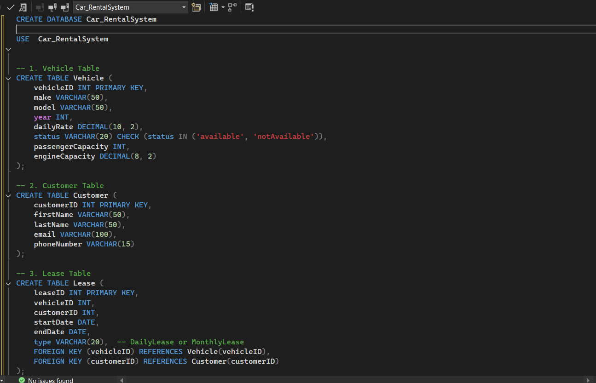

**-- Payment Table**

CREATE TABLE Payment (

paymentID INT PRIMARY KEY,

leaseID INT,

paymentDate DATE,

amount DECIMAL(10, 2),

FOREIGN KEY (leaseID) REFERENCES Lease(leaseID)

);

SELECT * FROM Vehicle

SELECT * FROM Customer

SELECT * FROM Lease

SELECT * FROM Payment

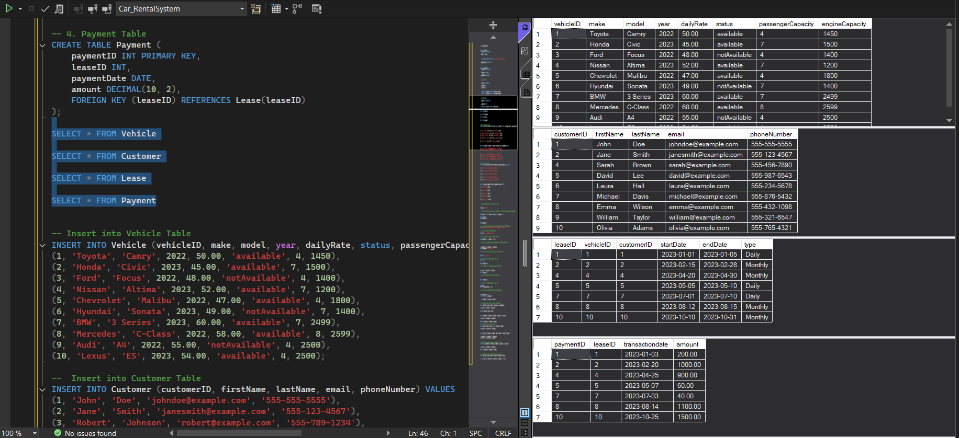

**-- Insert into Vehicle Table**

INSERT INTO Vehicle (vehicleID, make, model, year, dailyRate, status, passengerCapacity, engineCapacity) VALUES

(1, 'Toyota', 'Camry', 2022, 50.00, 'available', 4, 1450),

(2, 'Honda', 'Civic', 2023, 45.00, 'available', 7, 1500),

(3, 'Ford', 'Focus', 2022, 48.00, 'notAvailable', 4, 1400),

(4, 'Nissan', 'Altima', 2023, 52.00, 'available', 7, 1200),

(5, 'Chevrolet', 'Malibu', 2022, 47.00, 'available', 4, 1800),

(6, 'Hyundai', 'Sonata', 2023, 49.00, 'notAvailable', 7, 1400),

(7, 'BMW', '3 Series', 2023, 60.00, 'available', 7, 2499),

(8, 'Mercedes', 'C-Class', 2022, 58.00, 'available', 8, 2599),

(9, 'Audi', 'A4', 2022, 55.00, 'notAvailable', 4, 2500),

(10, 'Lexus', 'ES', 2023, 54.00, 'available', 4, 2500);

**-- Insert into Customer Table**

INSERT INTO Customer (customerID, firstName, lastName, email, phoneNumber) VALUES

(1, 'John', 'Doe', 'johndoe@example.com', '555-555-5555'),

(2, 'Jane', 'Smith', 'janesmith@example.com', '555-123-4567'),

(3, 'Robert', 'Johnson', 'robert@example.com', '555-789-1234'),

(4, 'Sarah', 'Brown', 'sarah@example.com', '555-456-7890'),

(5, 'David', 'Lee', 'david@example.com', '555-987-6543'),

(6, 'Laura', 'Hall', 'laura@example.com', '555-234-5678'),

(7, 'Michael', 'Davis', 'michael@example.com', '555-876-5432'),

(8, 'Emma', 'Wilson', 'emma@example.com', '555-432-1098'),

(9, 'William', 'Taylor', 'william@example.com', '555-321-6547'),

(10, 'Olivia', 'Adams', 'olivia@example.com', '555-765-4321');

**-- Insert into Lease Table**

INSERT INTO Lease (leaseID, vehicleID, customerID, startDate, endDate, type) VALUES

(1, 1, 1, '2023-01-01', '2023-01-05', 'Daily'),

(2, 2, 2, '2023-02-15', '2023-02-28', 'Monthly'),

(3, 3, 3, '2023-03-10', '2023-03-15', 'Daily'),

(4, 4, 4, '2023-04-20', '2023-04-30', 'Monthly'),

(5, 5, 5, '2023-05-05', '2023-05-10', 'Daily'),

(6, 4, 3, '2023-06-15', '2023-06-30', 'Monthly'),

(7, 7, 7, '2023-07-01', '2023-07-10', 'Daily'),

(8, 8, 8, '2023-08-12', '2023-08-15', 'Monthly'),

(9, 3, 3, '2023-09-07', '2023-09-10', 'Daily'),

(10, 10, 10, '2023-10-10', '2023-10-31', 'Monthly');

**--Insert into Payment Table**

INSERT INTO Payment (paymentID, leaseID, paymentDate, amount) VALUES

(1, 1, '2023-01-03', 200.00),

(2, 2, '2023-02-20', 1000.00),

(3, 3, '2023-03-12', 75.00),

(4, 4, '2023-04-25', 900.00),

(5, 5, '2023-05-07', 60.00),

(6, 6, '2023-06-18', 1200.00),

(7, 7, '2023-07-03', 40.00),

(8, 8, '2023-08-14', 1100.00),

(9, 9, '2023-09-09', 80.00),

(10, 10, '2023-10-25', 1500.00);

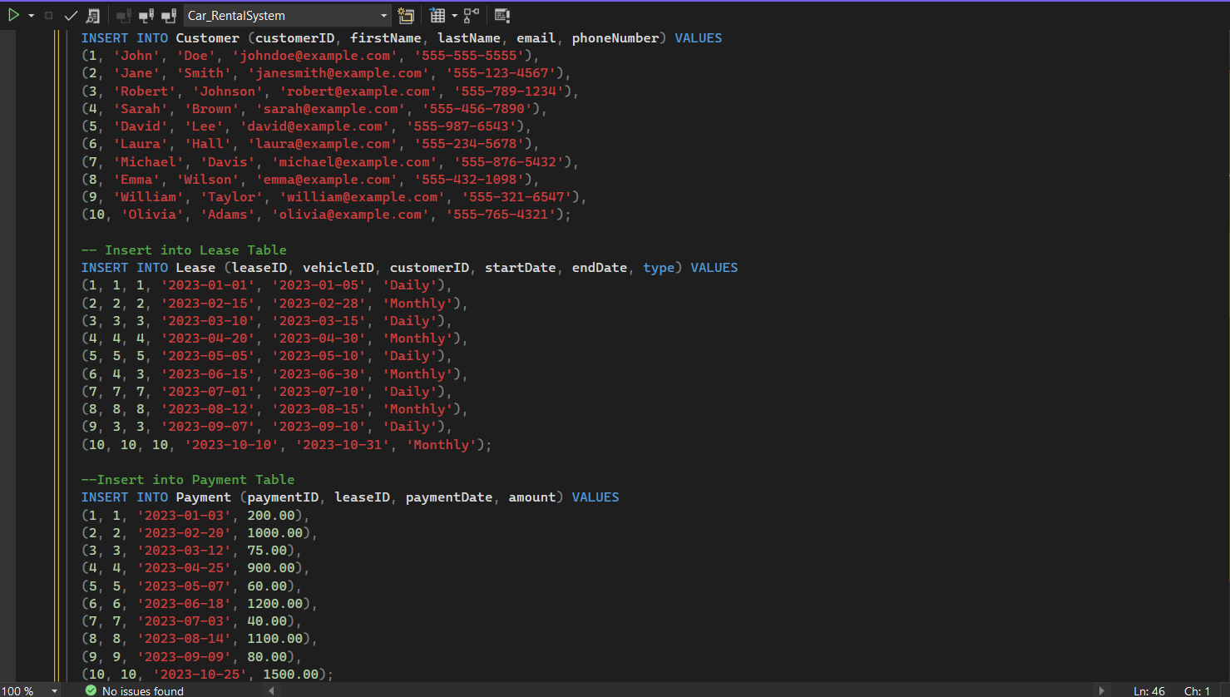

**-- 1: Update the daily rate for a Mercedes car to 68**

UPDATE Vehicle

SET dailyRate = 68

WHERE make = 'Mercedes';

**-- 2: Delete a specific customer (e.g., customerID = 3) and all associated leases and payments**

DELETE FROM Payment

WHERE leaseID IN (SELECT leaseID FROM Lease WHERE customerID = 3);

DELETE FROM Lease

WHERE customerID = 3;

DELETE FROM Customer

WHERE customerID = 3;

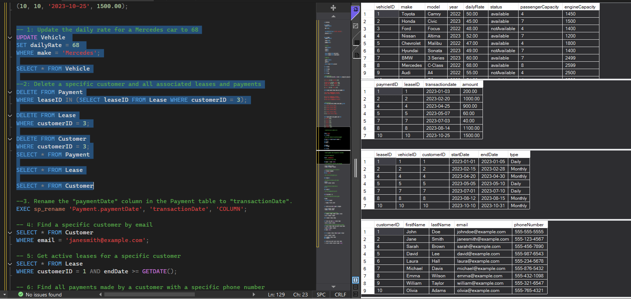

**-- 3: Rename the "paymentDate" column in the Payment table to "transactionDate"**

EXEC sp_rename '.Payment.paymentDate', 'transactionDate', 'COLUMN';

**-- 4: Find a specific customer by email**

SELECT * FROM Customer

WHERE email = 'janesmith@example.com';

-- 5: Get active leases for a specific customer

SELECT * FROM Lease

WHERE customerID = 1 AND endDate >= GETDATE();

**-- 6: Find all payments made by a customer with a specific phone number**

SELECT p.* FROM Payment p

JOIN Lease l ON p.leaseID = l.leaseID

JOIN Customer c ON l.customerID = c.customerID

WHERE c.phoneNumber = '555-876-5432';

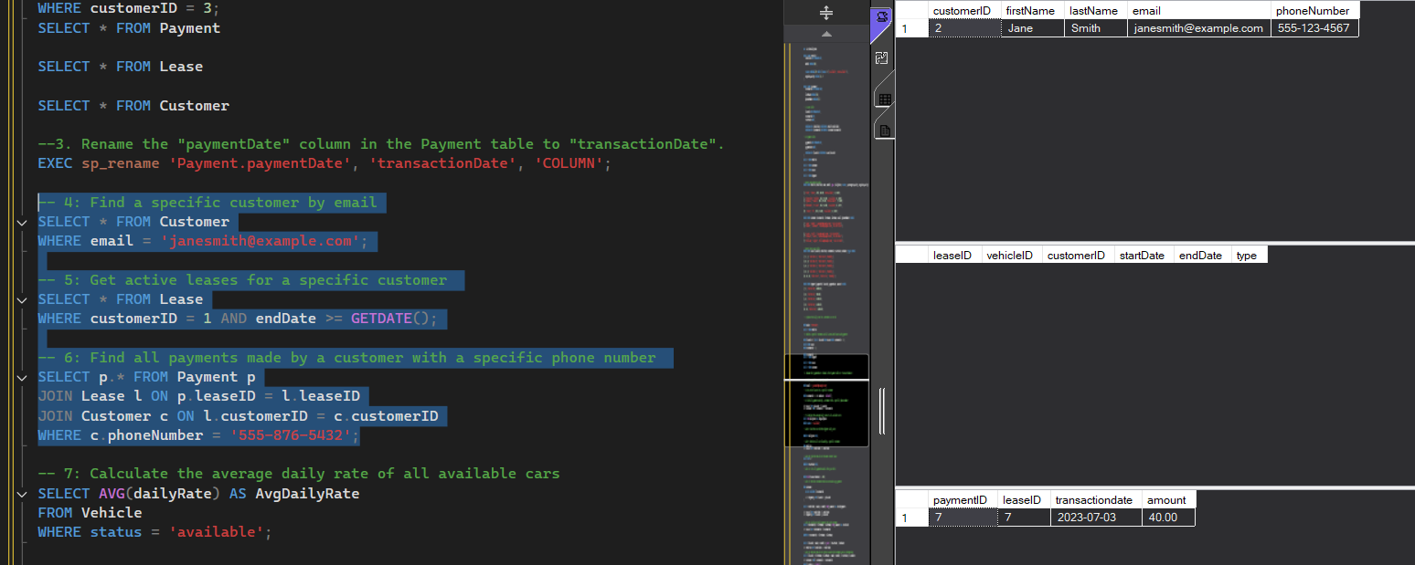

**-- 7: Calculate the average daily rate of all available cars**

SELECT AVG(dailyRate) AS AvgDailyRate

FROM Vehicle

WHERE status = 'available';

**-- 8: Find the car with the highest daily rate**

SELECT TOP 1 *

FROM Vehicle

ORDER BY dailyRate DESC;

**-- 9: Retrieve all cars leased by a specific customer**

SELECT v.*

FROM Vehicle v

JOIN Lease l ON v.vehicleID = l.vehicleID

WHERE l.customerID = 2;

**-- 10: Find the details of the most recent lease**

SELECT TOP 1 *

FROM Lease

ORDER BY startDate DESC;

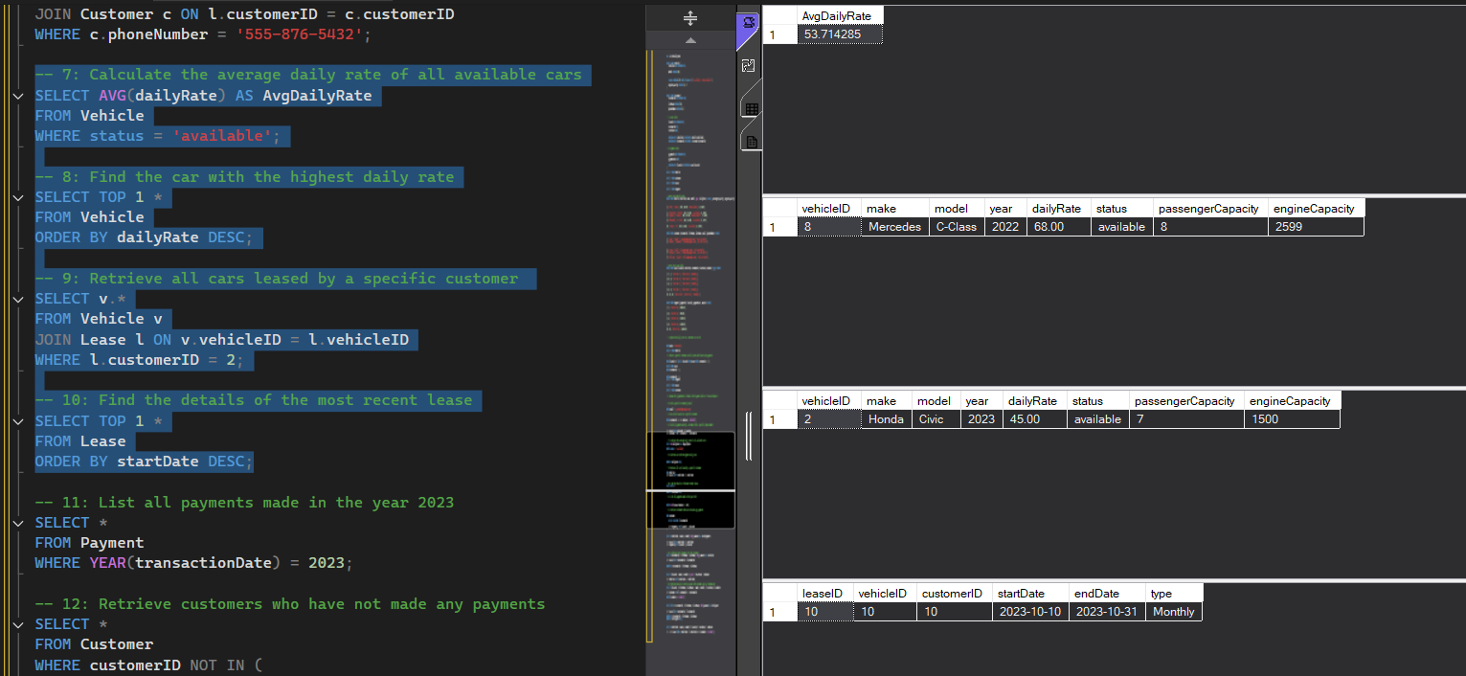

**-- 11: List all payments made in the year 2023**

SELECT *

FROM Payment

WHERE YEAR(transactionDate) = 2023;

**-- 12: Retrieve customers who have not made any payments**

SELECT *

FROM Customer

WHERE customerID NOT IN (

SELECT DISTINCT l.customerID

FROM Lease l

JOIN Payment p ON l.leaseID = p.leaseID

);

**-- 13: Retrieve Car Details and Their Total Payments**

SELECT v.vehicleID, v.make, v.model, SUM(p.amount) AS TotalPayments

FROM Vehicle v

JOIN Lease l ON v.vehicleID = l.vehicleID

JOIN Payment p ON l.leaseID = p.leaseID

GROUP BY v.vehicleID, v.make, v.model;

**-- 14: Calculate Total Payments for Each Customer**

SELECT c.customerID, c.firstName, c.lastName, SUM(p.amount) AS TotalPaid

FROM Customer c

JOIN Lease l ON c.customerID = l.customerID

JOIN Payment p ON l.leaseID = p.leaseID

GROUP BY c.customerID, c.firstName, c.lastName;

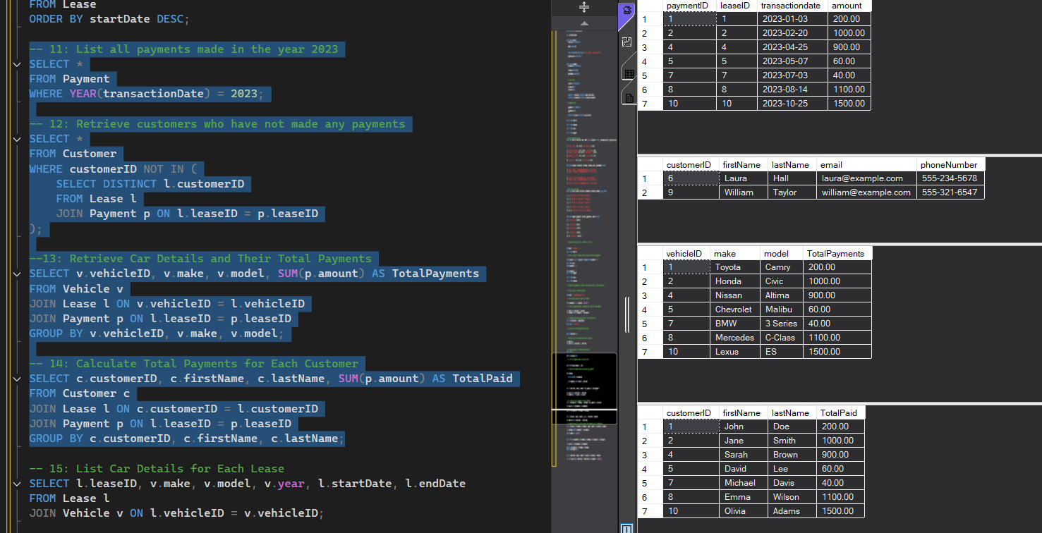

**-- 15: List Car Details for Each Lease**

SELECT l.leaseID, v.make, v.model, v.year, l.startDate, l.endDate

FROM Lease l

JOIN Vehicle v ON l.vehicleID = v.vehicleID;

**-- 16: Retrieve Details of Active Leases with Customer and Car Information**

SELECT l.leaseID, c.firstName, c.lastName, v.make, v.model, l.startDate, l.endDate

FROM Lease l

JOIN Customer c ON l.customerID = c.customerID

JOIN Vehicle v ON l.vehicleID = v.vehicleID

WHERE l.endDate >= GETDATE();

**-- 17: Find the Customer Who Has Spent the Most on Leases**

SELECT TOP 1 c.customerID, c.firstName, c.lastName, SUM(p.amount) AS TotalSpent

FROM Customer c

JOIN Lease l ON c.customerID = l.customerID

JOIN Payment p ON l.leaseID = p.leaseID

GROUP BY c.customerID, c.firstName, c.lastName

ORDER BY TotalSpent DESC;

**-- 18: List All Cars with Their Current Lease Information**

SELECT v.vehicleID, v.make, v.model, l.leaseID, l.startDate, l.endDate

FROM Vehicle v

LEFT JOIN Lease l ON v.vehicleID = l.vehicleID AND l.endDate >= GETDATE();

